**International University of Information Technologies**



**Web-technologies**

**Laboratory work**

**REPORT**

**Pak Artyom**

**Name of laboratory work: Lab_1.2**

**Year of study:** 1

**Group:** IT2CCO-2113

**Checked by:**___Alpysbay N. E.___

Almaty 2021

Introduction………………………………………………………………3

Main Part…………………………………………………………………4

Conclusion……………………………………………………………….5

References………………………………………………………………..6

# **Introduction**

Pet Shop project is website from where you are able to look for pets and everything for them with acceptable price.

The website Interface is based on HTML, CSS.

The definition of HTML is **HyperText Markup Language**.

* *HyperText* is the method by which you move around on the web — by clicking on special text called **hyperlinks** which bring you to the next page. The fact that it is *hyper* just means it is not linear — i.e. you can go to any place on the Internet whenever you want by clicking on links — there is no set order to do things in.
* *Markup* is what **HTML tags** do to the text inside them. They mark it as a certain type of text (*italicised* text, for example).
* HTML is a *Language*, as it has code-words and syntax like any other language.

What is **CSS**?

* CSS stands for Cascading Style Sheets
* CSS describes how HTML elements are to be displayed on screen, paper, or in other media
* CSS saves a lot of work. It can control the layout of multiple web pages all at once
* External stylesheets are stored in CSS files

**Main part:**

1.1 Main “Index.html” file

HOME PAGE:

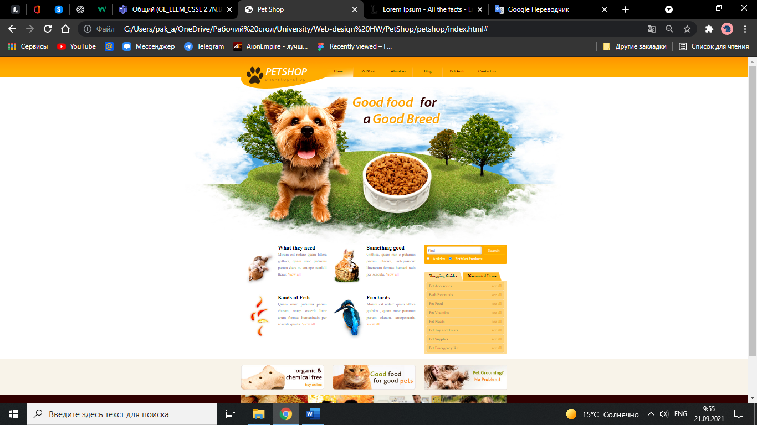

**Conclusion**

The pet shops features:

1. PetMart for customers.
2. PetGuide where clients learn some tips for caring for their pets.
3. Feedback via mail or phone.
4. Blog where customers can find the latest news.

**References**

1. <http://htmlbook.ru/>
2. <https://www.w3schools.com/css/css_intro.asp>